St. Emile School
552 St. Anne’s Road
Winnipeg, Manitoba
R2M 3G4

School Office: 204-989-5020
Email: awinter@stemileschool.com
Website: www.stemileschool.com

St. Emile School Handbook

OUR HISTORY
OUR MISSION STATEMENT

St. Emile School is a Christian community of learners dedicated to nurturing the development of capable, collaborative, contributing, and caring students. We strive to provide an inclusive education within a faith-based environment that fosters the spiritual, moral, intellectual, physical, social, and emotional growth of all members of our community. St. Emile School believes all children are a gift from God.
To achieve our goals, we have over 50 professional and support staff. The students’ learning experience includes: promotion of Christian values, a multimedia environment, a resource centre, school celebrations, an annual Christmas concert, a learning fair, and a dynamic sports program. On behalf of the entire St. Emile community, welcome to our school!

St. Emile Parish was founded in 1941 while St. Emile School was founded by Father Lionel Bouvier in 1960. In its first year, there were 26 students and today more than 340 students attend St. Emile. We offer Pre-Kindergarten to Grade 8 programming. The school is located at 552 St. Anne's Road, one block south of Bishop Grandin Boulevard.

St. Emile School is part of the St. Emile Parish and as such is part of the Archdiocese of St. Boniface. St. Emile’s professional and dynamic staff of teachers includes Pre-Kindergarten to Grade 8 classroom teachers, a team of Educational Assistants, as well as Physical Education, Resource, Music, and French specialists. We also have the support of Louis Riel School Division clinicians including a speech and language therapist, psychologist and social worker. The Manitoba Education, Citizenship and Youth Curriculum and the Catholic religious programs are taught at all grade levels.

St. Emile School is part of the
Archdiocese of St. Boniface and Manitoba Catholic Schools.

Table of Contents

Drop off and Pick Up 2 School Uniform Policy 7
School Board 3 Color Days 7
Parent Association & Supervision 3 Homework 8
Volunteer 3
Student Support Services 3
School Hours 4 Code of Conduct 9
Before and After School Care Program 4 Attendance and Punctuality 9
Attendance/Call Back Policy 4 Readiness 9
School Visitors/Teacher Meetings 4 Respect for Authority 9
Student Illness 4 Respect for Property and Others 10
Lockers 4 Internet & E-mail 11 Curricular & Extra Curricular 5 Playground Rules 11
Student Leadership Opportunities 6 Range of Consequences 12
Lunch Program Policy 6 Technology Policy 13
Classroom Library 6 Internet Guidelines 13
Milk Program 6 Cell Phone & Device Guidelines 14
Personal Property 6 Bullying Prevention Policy 14
Communication 7 Fire and Lockdown Drills 15

Drop Off & Pick Up
Drop Off & Pick Up

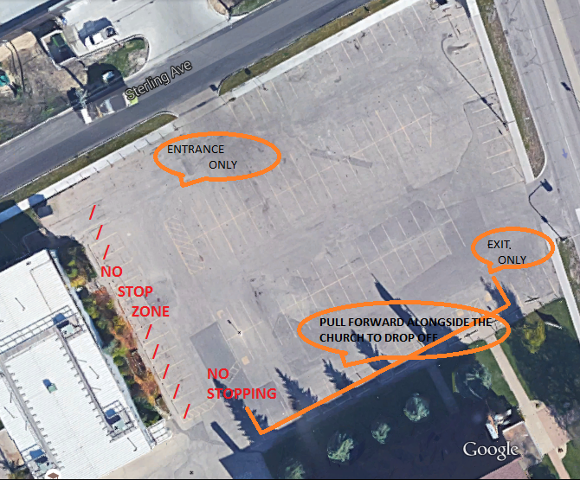
Dropping Off
Enter only from Sterling Ave.
Turn right and drive around to the church if you are not parking.
Turn left into the parking lot if you are going to park.
Park in the parking stalls if you are going to get out of the vehicle.
Pull forward as far as you can alongside the church to drop and go.
Children must only exit on the passenger side of the vehicle.
DO NOT stop in front of the school to drop off.
Everyone must use the crosswalk
All bikes must be dismounted.
Picking Up
Enter only from Sterling Ave.
Turn left and park in a stall.
Exit only onto St. Anne’s.

Please be patient and respectful of others at all times. Alert the office of any drivers not following the rules and we will remind them of our policies.

The safety of our students, staff and families is our number one priority. The effectiveness of any plan is largely determined by how closely it is followed. Please carefully review these rules and share them with anyone that will be driving your children to school.

Student Supervision / Drop-Off and Pick up Policy

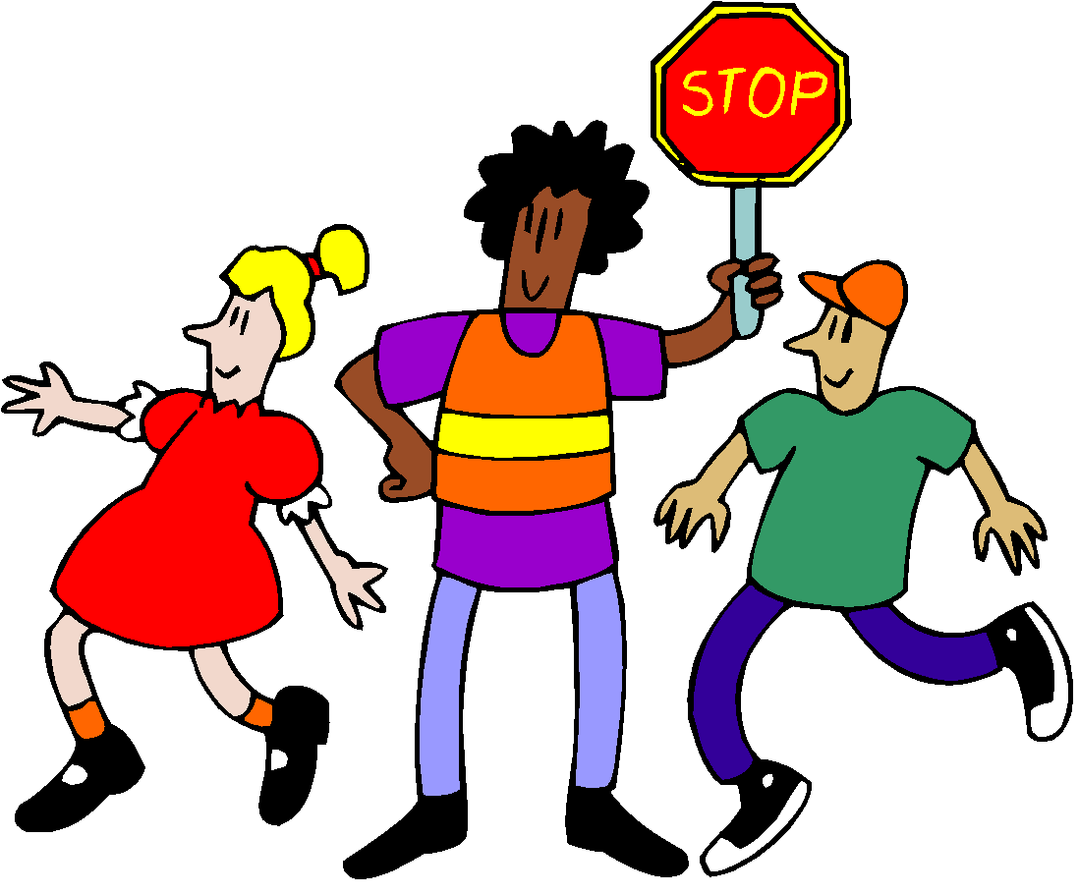
Students who are not in the Before &/or After School Program should not be on the school grounds or inside the school before 8:30 am or after 3:30 pm.
Supervision of students begins at 8:30 am. Students are not supervised after 3:30 pm and are expected to leave promptly.
There are grade 5/6 volunteer patrols on duty to assist with parking lot safety from 8:30 a.m. – 8:45 a.m. and from 3:30 p.m. - 3:45 p.m. Any students remaining on the school grounds after 3:45 p.m. will be sent to the After School Program and charged accordingly for this service.
School Board

The St. Emile School Board consists of elected volunteer members who work in conjunction with Administration to set policy and ensure the needs of the school are met through monthly meetings.

Non-board members are welcome to attend meetings with advance notice to the office. The board also welcomes any parents/guardians interested in becoming board members to contact the board chairperson or principal. Board members are elected each year at our Annual General Meeting in October.
Parents’ Association

The St. Emile Parents’ Association, of which all parents and guardians are members, performs two core functions. One is to raise funds for our school and students by coordinating various fundraising events throughout the school year. Funds raised are used to support curricular needs, school beautification, field trips and activities.
The second function is to participate in fostering a strong community school spirit through regular meetings and school-wide events.
Parents are encouraged to attend the monthly meetings. Please contact the PA at parents@stemileschool.com if you have any questions or suggestions.
Volunteer Opportunities

Adult volunteers play a vital role in the St. Emile community. Volunteer opportunities may include coaching, field trip supervision, fundraising and a variety of classroom tasks. All volunteers must complete both a Child Abuse Registry Check and a Criminal Record Check if they are working with children or handling money.
Student Support Services

The Student Services team is comprised of resource teachers and educational assistants. The team works with students, teachers, clinicians and parents to help students reach their full potential.
St. Emile School is an inclusive community. Our team develops Adapted Learning Plans, Behaviour Intervention Plans, and Individualized Education Plans to help students meet the outcomes of the Manitoba Curriculum. The team also supports the social and emotional needs of our students.
Shared services through Louis Riel School Division provide the support services of a psychologist, social worker, and a speech language pathologist.

Regular School Hours

Pre-K & Kindergarten 8:45 a.m. – 3:15 p.m.
Grades 1-8 8:45 a.m. – 3:30 p.m.
Early Dismissal is the 4th Tuesday of each month at 2:15 p.m. (2:10 for Pre-K & Kindergarten)
**hours may be subject to change to accommodate staggered schedules**
Before and After School Care Program

St. Emile School offers a supervised before and after school program to all families who have registered and paid for its use. The program begins on the first day of school, operating from 7:00 a.m. – 8:30 a.m. and 3:30 p.m. – 6:00 p.m. each school day (the program does not operate during all staff professional development/administration days, Christmas Break, Spring Break or summer holidays).
For the safety of our students, all children must be signed out of the program by an authorized person. I.D. will be required if the person picking up is not known to our staff.

Attendance/Call back Policy

If for any reason your child is unable to attend school or will be late, please notify the office or the classroom teacher before 8:30 a.m. If we do not hear from you, we will call your cell phone to ensure your child is safe and secure. Please ensure your contact numbers and email addresses are up to date!
School Visitors

For the safety and well-being of students and staff, we require ALL VISITORS to report to the office upon arrival at the school, sign in for a visitor’s pass and wear it for the duration of their visit.
Student Illness

We do not have the facilities or staff supervision at school to accommodate children who are ill. If your child is too ill to go outside at recess or participate in school activities, please keep your child at home. If they become ill after their arrival at school, parents will be called to pick up their child.

Lockers

Students are assigned either a cubby with hooks, or a locker. Students are responsible for keeping their area clean, tidy and free of decoration. Students in grades 6-8 will be encouraged to bring their own combination lock to use on their locker. Teachers will keep a record of the combinations. Administration reserves the right to inspect a student’s locker at any given time.

Co-curricular and Extra Curricular Activities

School Celebrations
A monthly Eucharistic Celebration is held at the church. All children attend and participate in the preparation and singing during mass. We also plan celebrations during Advent, which are held in the gym, and finally our annual spring celebration at St. Vital Park.

Hockey Development Program
Grades 2-8 students with two years of hockey experience are welcome to apply to the Hockey Program. Students will experience 45+ ice times as well as ongoing evaluations and reports.

Learning Fair
Each spring, St. Emile School endeavors to celebrate learning through a school wide event. This may be presented as a concert or a learning fair that focuses on one area or theme (ex. Science or technology).

School Choir
The school choir is composed of students in grades 3 & 4. The choir leads the singing at our monthly celebrations and performs at other special school and community events.

Student Council

An elected student government makes up the student council, coordinating activities for the entire student body.

Industrial Arts
Grade 7 & 8 students attend Victor Wyatt School once per 6-day cycle to attend a variety of classes in woodworking, metals, textiles, food and nutrition, graphic design and engineering.

UNESCO Associated School
St. Emile School is a UNESCO (United Nations Educational, Scientific and Cultural Organization) associated school. We strive to establish a culture of peace and promote democracy, human rights and mutual understanding through both curricular and extra-curricular projects related to:
- world concerns and the role of the United Nations
- human rights / democracy
- intercultural learning
- environmental issues

Christmas Concert
The St. Emile Christmas concert is a dramatic and musical production involving all students from Pre-K - Grade 8, with the Grade 6 students starring in the acting roles.

Outdoor Education
Our students begin to embark on outdoor overnight adventures in grade 5. There are winter and spring trips for students in grades 6-8.

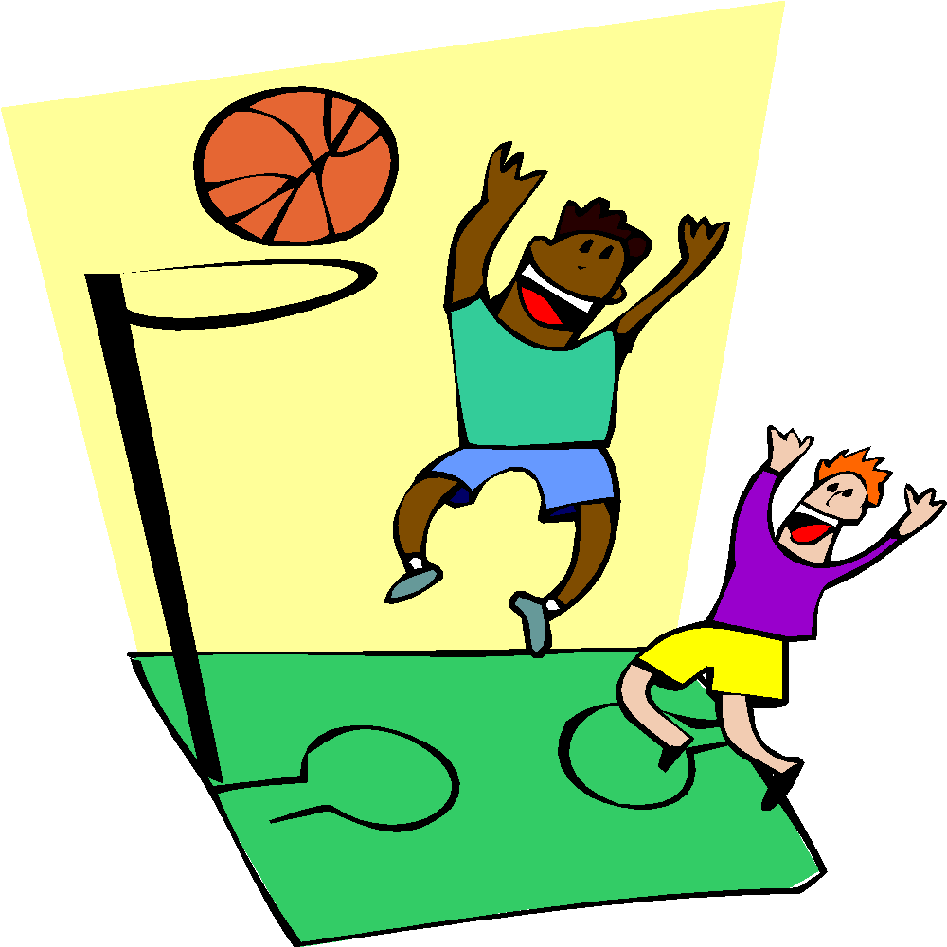
Sports Programs
Our school participates in the Manitoba Catholic School Association League and competes with other independent and public schools in Winnipeg in volleyball, basketball, badminton, running club, and track and field. We also play host to sports camps and intramurals for students throughout the year.

Student Leadership Opportunities

Our students are encouraged to develop leadership skills and responsibility through activities such as:
- lunch monitors
- microwave helpers
- safety patrol program
- a multi-grade buddy system for various school activities
- an active student council made up of students from each grade level
- special events’ ambassadors (i.e. learning fair, open house, reading month, etc.)
- peacekeepers’ program during outdoor recesses
- delivering hot lunches and milk

Lunch Program Policy

All students remain in their classrooms to eat lunch. Supervision is provided by staff and student monitors. The lunch program is a privilege. Any student who consistently displays inappropriate or disruptive behavior will be required to make other arrangements for the lunch hour. Students are NOT allowed to leave the school premises during the lunch hour without parental permission.
Classroom Library

Each classroom is equipped with a wide variety of reading materials. Students will have access to fiction, non-fiction, reference and levelled stories to meet diverse reading abilities within the classroom. Teachers have gathered reading material that is age, grade and curricular appropriate.

Milk Program

St. Emile offers a milk program sponsored by the Manitoba Milk Marketing Board. We have been a part of this program for over 20 years! Students may pre-purchase a 237 ml carton of milk (chocolate or white) for $.90 each to enjoy with their lunch each day. Orders are placed monthly.

Personal Property

Please ensure that all of your children’s clothing & supplies are clearly labelled with their name because many children have identical or similar items. We maintain a lost and found that is always accessible to students and sorted and displayed several times a year for families. Unclaimed items will be donated at the end of each year.

Communication

Most communication between the school and families will be electronic. Please check your e-mails regularly and ensure we have updated information.
We also offer communication using the following:
- School website: stemileschool.com (with classroom links)
- Teacher blogs
- Student planners for grades 1-6.
- A phone for students to use (with their teacher’s permission) is located in the office.
School Uniform Policy

St. Emile School has a school-wide uniform that all students from K-8 must wear. All tops must be purchased from Top Marks (www.topmarks.ca school code EMI01). Top Marks will come to the school each spring for a uniform fitting session. Used uniform pieces will be available for purchase at different events throughout the year.
All grades:
- White or navy blue, matching socks or tights
- Indoor shoes with non-marking soles
- Outdoor shoes must be removed at the entrance doors.
- If worn under uniform, all undershirts must be white only and short-sleeve.

Boys: Grades K-5 Grades 6-8
- Navy uniform pants or shorts >Navy uniform pants or shorts
- Short sleeve white polo shirt >Short sleeve white button shirt
- Navy zippered hoodie or sweater >Navy zipper sweater only

Girls: Grades K-5 Grades 6-8
- Navy pants, shorts, tunic, skort, or box pleat skirt >Navy pants or kilt
- Short sleeve white poplin blouse or >Short sleeve white poplin blouse
- Short sleeve white polo shirt >Navy zipper sweater
- Navy zippered hoodie

Physical Education: Grades 2 – 8
- Navy shorts
- Navy St. Emile gym t-shirt with logo

The uniform policy is enforced by all staff. Failure to comply will result in a phone call home requesting proper attire. Continued disregard for the policy will result in the student being removed from the classroom until a proper uniform is worn.
Uniforms are mandatory for all field trips, except when administration authorizes an exception.
Casual Days

Throughout the year there will be opportunities for students to dress in casual clothing. These days will include early dismissal days (the fourth Tuesday of each month).
Casual Dress Code Standards:
** Students are to appear neat at all times**
- Skirts and shorts are to be knee length or no shorter than 2 inches above the knee (no slits).
- All clothing worn at school is to be in good repair (no holes or stains).
- No patterns or logos deemed “un-Christian” are permitted.
- No hats are to be worn indoors.
- All shirts must have sleeves and cover one’s midriff.
- Ripped jeans & pajama pants are not acceptable.
Homework

All students are required to have all materials (books, homework, student agenda etc.) and assignments completed each day, ready for class participation. We believe that good study skills and homework routines should start early. The following are suggested guidelines:

Kindergarten - Grade 2:
15-20 minutes per day including daily home reading, math practice and weekly spelling words in grades 1&2. Incomplete assignments may be sent home for completion and special projects may be assigned throughout the year.

Grades 3&4:
20-30 minutes per day including home reading, math practice and weekly spelling words. Incomplete assignments may be sent home for completion and special projects may be assigned throughout the year. Students will be expected to study for quizzes and tests at home.

Grades 5-8:
30-60 minutes per day. Homework will be assigned in a variety of subjects. Incomplete classwork will be sent home for completion as well as special projects as assigned. Students will be expected to study for quizzes and tests at home.

Students K- Grade 2:
20-30 minutes per day
Daily home reading
Daily math practice
Spelling words will be given each week (Gr 1 & Gr 2)and daily practice is required
Incomplete assignments may be sent home
Special projects may be assigned throughout the year
Students Grade 3-4:
30-45 minutes per day
Daily home reading
Daily math practice
Weekly spelling tests
Incomplete assignments may be sent home
Special projects may be assigned throughout the year
Students will be expected to study for quizzes and tests at home
Code of Conduct

_________________________Attendance and Punctuality_______________________
Students will:
- Attend school and classes regularly and punctually.
- Leave the school grounds promptly when dismissed unless parents are on site supervising.
- Report to the office when arriving late

Parents will:
- Ensure regular attendance.
- Notify the school by phone, email or note, before 8:30 am, if the student will be late, absent or needing to leave early.
- Notify the teacher, office and principal before taking the child out of school for any extended absence.

St. Emile School will:
- Keep accurate records of attendance.
- Adhere to a call-back policy to determine the reason for any absences.
- With advance notice, assign “take home” work for students on an extended absence.

______________________________Readiness_______________________________
Students will:
- complete all assignments on time.
- have all supplies and materials ready for each school day
- participate to the best of their ability
- communicate with their teacher after any absence(s) and complete missed assignments

Parents will:
- prepare students for school each day
- encourage completion of assignments
- encourage a productive day
- stay informed about classroom deadlines and tests

St. Emile School will:
- deliver the curriculum
- keep accurate and current records
- provide a clear outline of expectations and required materials

_ Respect for Authority____________________________
Respectful Workplace Policy
‘No one, whether they are a staff member, student, parent, volunteer or visitor should be subject to discrimination, harassment, bullying, disrespectful or violent behavior, for any reason, at any time. And no one has the right to discriminate against, harass, bully, show disrespect or violence towards anyone else, at work or in any situation related to employment’ – Government of Manitoba Labour and Immigration- Workplace Safety and Health Division Regulation #M.R 217/2006. February 1, 2011.
Students will:
- Recognize, accept and respond to all levels of authority within the school.
- demonstrate behaviour that contributes to an orderly, supportive and safe learning environment
Parents will:
- Encourage respect for all levels of authority within the school.
- Adhere to Workplace Safety & Health Division regulation #M.R.217/2006 in all e-mail, telephone, and in - person meetings.

St. Emile School will:
- Adhere to Workplace Safety & Health Division regulation #M.R.217/2006
- Enforce school policies consistently.

___________________________Respect for Property_________________________
Students will:
- Be respectful and responsible for public, school, personal property and the property of others
- Encourage pride in their surroundings and their school

Parents will:
- Label all student property, supplies & clothing

St. Emile School will:
- Provide a clear outline of expectations

___________________________Respect for Others___________________________

All members of St. Emile School Community have a responsibility in contributing to and ensuring a safe and secure learning environment.

Students will:

- respect the rights of others.
- refrain from using intimidating gestures, words or actions.
- not tolerate or use inappropriate language and/or comments against race, religion, ethnic background or gender.
- resolve conflict and challenges through discussion or assistance from school personnel.
- ensure that all lunches and snacks are nut and tree nut free.
- observe and respect a fragrance free policy in our school.
- respect a no cell-phone use policy. During school hours, cell phones may only be used with staff permission and supervision.

Parents will:

- respect the rights of others.
- refrain from using intimidating gestures, words or actions.
- not tolerate or use inappropriate language and/or comments against race, religion, ethnic background or gender.
- resolve conflict and challenges through discussion or assistance from school personnel.
- ensure that all lunches and snacks are nut and tree nut free.
- observe and respect a fragrance free policy in our school.
- support the St. Emile School Code of Conduct and all school policies.

St. Emile School will:

- Provide a clear outline of expectations.
- respect the rights of others.
- refrain from using intimidating gestures, words or actions.
- not tolerate or use inappropriate language and/or comments against race, religion, ethnic background or gender.
- promote fair and equitable treatment of all students.
- provide appropriate role models.

______________________Internet and Electronic Mail________________________
Students will:
- Respect appropriate use of electronic mail and the internet, including the accessing, uploading, downloading, possessing or distributing materials that the school has determined to be objectionable (see computer user policy)
- turn off and store all cell phones, smart watches and other electronic devices in their locker

Parents will:
- remind students that access to computers, the internet and e-mail is for educational purposes only
- support the school’s cell phone use policy and call the school office with any messages for their children during school hours

St. Emile School will:
- Provide clear expectations of use and accessible content
- provide a telephone for student use

______________________ Other ________________________

Using, possessing, or being under the influence of alcohol or illicit drugs, including tobacco, cannabis, e-cigarettes, and vapes, on school property or on school related activities inside or outside the school property may result in suspension or expulsion from the school.

Playground Rules

In order to maintain student safety, we have established a set of rules for all students to follow. Each grade is assigned certain days to use the play structure. Having students of similar age on the play structure is key to reducing injury. The ‘back field’ is the area west of the fence where the soccer nets are located. This area is set aside for the older children. Only students from grade 5 – 8 are allowed in that area during recess.
At all times, our students are expected to respect the rights of others and their property.

Play Structure Safety Rules:
- Playground equipment should be used appropriately and safely.
- Students will go down the slide, one at a time, feet first and on their bottom.
- No running or walking up the slides.
- Tag and grounder games are not to be played on the structure.
- Shoes must be worn on the structure.
- Students may not climb on the top of any part of the structure.
- Students must not push or pull other students while on the structure.
- Students may use the structure after 3:30 pm, if supervised by a parent.

Swing Safety Rules:
- Always hold on with both hands.
- No standing, doubling or twisting on the swings.
- No jumping off the swings when in motion.
- Stand clear of moving swings to avoid injury.

Range of Consequences

We believe:
- Consequences should be fair but not necessarily equal.
- Consequences teach about behaviour.
- Consequences should not be punishments.
Effective discipline achieves four goals. It shows students what they have done wrong, gives them ownership of the problems created, gives them ways to solve the problems, and leaves their dignity intact.

Consequences that support the development of inner discipline may include, but not be limited to the list below. The individual nature of a student’s behaviour will be given consideration when determining appropriate consequences.

- Informal Discussion: All concerned parties will meet with the student to reach an agreement regarding the student’s behavior.
- Behaviour Log Book: Behaviour will be recorded in a binder in the office, and may involve a student meeting with administration. If a student is written in the book three times, a call will be made to parents notifying them of the behaviours.
- Conference: A conference may be held with the student, teacher, administrator and appropriate staff to develop a plan of action. Parents may be notified/involved.
- Parental Involvement: The parent will be contacted to discuss the specific behavior of the student and steps that must be undertaken to change the behavior. The nature of the contact may vary from a telephone conversation to a formal meeting at the school involving the parent, student and school personnel.
- Withdrawal from Classroom Setting: The student will be temporarily removed from the classroom setting and relocated to a supervised alternate location.
- In-school Suspension: The student will be withdrawn from the classroom setting and relocated to a supervised alternate setting.
- Removal of Privileges: Access to playground and participation in field trips, outdoor recess, extra-curricular activities, and special events will be removed. The school will notify the parents when such privileges are removed.
- Restitution: The student or parent may be required to compensate for damages incurred. Such restitution may be monetary in nature but could take alternate forms.
- Behavioral/ Performance Contract: In some instances, the student will be required to meet specific behavioural standards. Such behavioural plans are documented with copies provided to all concerned parties.
- Formal Administrative Interview: Incidents will be documented and parents will be notified. If required, a meeting will take place with parents, administration and appropriate staff. The student must commit to a written plan of action designed to modify the underlying behavior. Behavior will be monitored and documented over a period of time, after which a follow up conference will take place.
- Suspension: In-school and out-of-school suspension from school is a serious consequence that is imposed subject to administrative discretion.
- Outside Agency: Whenever necessary, the appropriate outside agency will be notified. Some examples include Child and Family Services, Police, Truancy Officer, and the Child Guidance Clinic.
- Expulsion: In rare circumstances, a student’s behavior may be deemed severe enough that he/she will be asked to withdraw from the school.

Technology/ Acceptable Use Policy

Introduction
This policy outlines the expectations that St. Emile has adopted with regards to the use of school computers, laptops, tablets and the internet. This Acceptable Usage Policy is meant to cover student activity with respect to on-site computers and is meant to lay a foundation of understanding between staff, teachers, parents and students. It is also intended to educate parents with regards to the steps St. Emile School is taking to ensure that the internet and computer technology is being used in a responsible manner.
Student Use of Computers

The use of computer technology shall be consistent with the purpose, mission and goals of St. Emile School and used only for educational purposes. The purpose in providing computer and technology services for your child is to facilitate their learning experience by accessing electronic resources and tools.

Students will:
- treat all equipment with respect and care at all times.
- be held financially responsible for damage to any technology item should it be deemed intentional.
- access devices using a school provided login ID and password. Students must keep this information confidential at all times.
- not attempt to install software or change system settings on any device.
- not eat or drink near any equipment.
- not save, copy, distribute or store music files on your network account or school device
- not enter, or attempt to enter, any account for which you do not have permission.

Internet guidelines

Access to the internet is provided throughout the school. We have taken precautionary measures to ensure that our students are not being exposed to inappropriate content.

St. Emile School receives content filtering through Merlin (www.merlin.mb.ca) and Google Education. Content filtering tools provide the following protection:
- Blocking websites based on a categorized database.
- Providing St. Emile with the tools to selectively add and block access to websites and services.

Student Guidelines
- All devices may only be used with staff permission.
- Students will not access personal accounts online including, but not limited to, web hosting, webmail, chat, ‘FaceTime’, ‘iCloud’ or any similar services without staff permission.
- Students will not use technology to harass, insult or bully others
- If accidental viewing of inappropriate content takes place, students must notify a staff member immediately.
- Access to the Internet at our school is a privilege. This privilege may be suspended at any time for inappropriate use.

We make every effort to directly supervise all students while accessing internet-based resources. We cannot guarantee that a student will never be exposed to upsetting or inappropriate content However, we do take the utmost care to minimize the risk. The combination of Merlin content filters and direct supervision create a safe internet learning environment for all of our students.

Cell Phone/Telecommunication Device Policy

As technologies continue to advance, so have the implications related to safety, privacy, and the intrusive use of these devices. We take responsibility for governing the use of these devices to ensure the safety of the learning environment and all staff and students. Cell phones have disrupted the school environment unlike any other technological advancement. We have identified the following potential issues with students having these devices on school property.

The Challenges of Cell Phones and Personal Devices in the School Environment:

- Cell phones ringing in class and disrupting the lesson.
- Students using a cell phone to call home when feeling ill without informing the school.
- Students sending messages to each other during class time.
- Students using a device camera to take still photos or videos of other students without permission. These images may be uploaded to the Internet without the other student’s knowledge.
- Students recording video in the classroom, bathroom or playground without permission.

Guidelines for Student Use:

- Students are allowed to have a cell phone or other device on school property.
- Cell phones and other devices must be turned off and kept in the student’s locker at all times during school hours.
- Devices will never be used to take or upload photos or videos on school property at any time without the permission of everyone who appears in the picture/video.

Consequences for Infractions:

- First: device is confiscated until the end of the day.
- Second: device is confiscated- to be returned only to the parent or guardian.
- Third: student loses privilege of having a device at school and further disciplinary action may be administered at the discretion of the principal. This may include an in-school suspension or, in extreme cases, an out of school suspension or expulsion.
Bullying Prevention Policy

At St. Emile School, we are committed to providing a safe learning environment that is caring and compassionate and provides our students with every opportunity to grow to their full potential in all areas- physically, socially, intellectually, spiritually and emotionally. Part of our character education includes teaching our students that any form of bullying is not acceptable.
What is Bullying?
Bullying has been defined as ‘repeated, unwanted, aggressive behavior that involves a real or perceived power imbalance that is intended to hurt another individual physically, mentally, or emotionally’.

What Are Some Signs or Effects of Bullying?
The child being bullied may experience lower self-esteem, anxiety, headaches, stomachaches, self-blame, lower academic achievement, and avoidance of school and absenteeism.

Bullying Prevention and Education

Bullying behavior will not be tolerated, and at the discretion of the principal, may result in suspension or expulsion.

Students will:
- understand that every incident or conflict may not be interpreted as bullying.
- learn and apply conflict resolution skills to resolve disputes
- report any incidents of bullying to a staff member
- refrain from participating in bullying behaviour

Parents will:
- Inform staff if their child discloses any incidents of repeated conflict.
- Encourage and teach effective conflict resolution skills
- Support the school’s no violence policy

St. Emile School will:
- Educate students to recognize bullying
- Communicate to students the effects and consequences of bullying
- Acknowledge positive behaviour among students
- Ensure students are supervised at all times during the school day
- Thoroughly investigate all suspected or reported incidents of bullying
- Enforce a no bullying policy

Upon learning of a bullying situation the school will:
- Begin the investigative process to gather information.
- Ensure appropriate action and consequence for the students involved.
- Provide support to the student who has been bullied.
- Contact parents of all students involved.

Fire and Lockdown Drills

Fire and lockdown drills are held regularly to ensure the school can be evacuated in an orderly manner in case of an emergency. Shoes must be worn at all times as fire drills are unannounced and every person must leave the building when the fire alarm sounds.
The purpose of emergency drills is to protect as many people as possible from imminent danger inside the school. Executing drills quickly will potentially save lives, reduce injuries, and will assist the police and other emergency responders in dealing with the situation effectively.
There are three different types of lockdown drills, each announced by its own specific phrase over the school’s public address system. They are as follows:

School Lockdown Phrase:
“Activate Lockdown, Activate Lockdown, Activate Lockdown – NOW”

- Restricts the movement of staff and students due to a threat of violence within the school
- All students will be provided with a safe location for the duration of the incident
- School will be completely locked down until confirmation is received that the threat is over

Hold and SecurePhrase:
“Attention All Staff – the school is now in Hold and Secure. Attention All Staff – the school is now in Hold and Secure. Attention All Staff – the school is now in Hold and Secure.”

- Involves an emergency situation occurring outside of, but not related to the school(i.e. criminal offence in the area)
- All students will be locked in the school with staff members, allowing only known people to enter the building

Sheltering in Place Phrase:
“Attention All Staff – the school is now in Sheltering in Place mode. Attention All Staff – the school is now in Sheltering in Place mode. Attention All Staff – the school is now in Sheltering in Place mode.”

- Involves a situation where leaving the school may pose a safety issue, often due to environmental dangers
- All staff and students must stay in the school building and take protective measures as instructed by office staff over the personal address system

